OS Proje

Dennis Lin,

Phonepaseuth Viengxay,

Ricky Viengxay

Patrick Bobbie

April 23, 2018

**Table of Contents**

Introduction

Design Approach

Implementation Modules

Central Processing Unit

CPU Module

DMA Module

Scheduling

LongTermScheduler Module

ShortTermScheduler Module

Dispatcher Module

Memory System

MMU Module

RAM Module

Disk Module

Page Module

Driver Module

Loader Module

Process Control Block

PCB Module

PCBManager Module

Helpers Module

GUI Implementation

MainFrame

ConsoleConstructor Module

ConsoleStream Module

CPUMetricsPanel Module

OSMetricsPanel Module JobTable Module

MetricsDialogue Module

Simulation and Data Analysis

1 CPU Core simulation and Data

Priority Scheduling Results

First In First Out(FIFO) Scheduling Results

Shortest Job First Scheduling Results

N­CPU Cores Where N = 8 CPU Cores

Priority Scheduling 8 CPU Cores Results

First In First Out(FIFO) Scheduling 8 CPU Cores Results

Shortest Job First() Scheduling 8 Core Results

1 CPU Core vs. 8 CPU Cores(N­CPU)

Conclusion

Introduction

The purpose of this document is to inform you on our ideas and thought process on how we tackled this Operating Systems project. As a group, we collectively decided the most optimal programming language to use for this project was C++, because of its strong pointer functionalities and flexibility. To work around conflicting schedules, we decided to use GitHub, as our source to share and modify files. Our choice of IDE was CLion. When possible, we as a team would find a day out of the week to come together and discuss our progress, problems, and future work that needed to be done. Some of the difficulties faced with this project include communication throughout, as many of us had different time schedules, interpreting some of the instructions which were provided, and finding the most optimal design to get the OS working properly.

# Design Approach

Our team first reviewed the project specification block diagram that was provided to us to understand how our system would work cohesively together. During phase one, we went through multiple trial and errors with our schematics design, which caused us to continuously revise our approach to our operating system. As we built the operating system, we would find flaws within our approach and discover new approaches that would not only resolve our problems but make it more efficient. As a result, the continuous revisions would solidify our schematics design for our operating system.

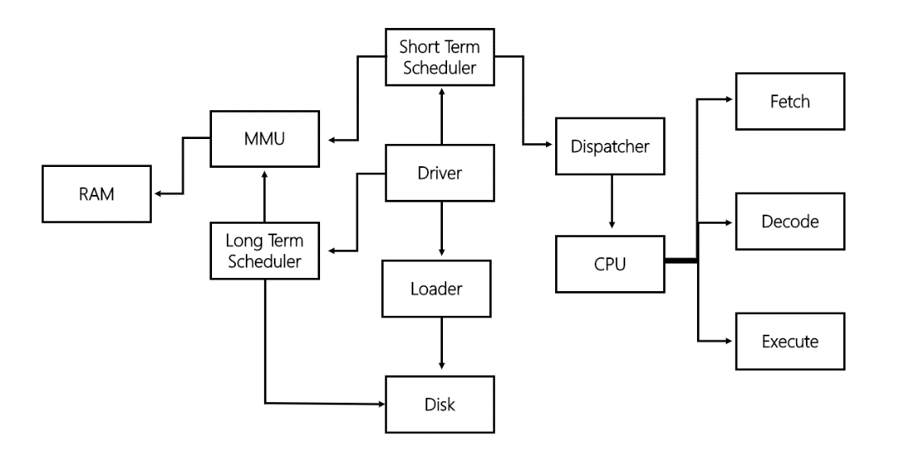

The main components that we pulled out were the CPU, the Short Term Scheduler, the Long Term Scheduler, the MMU, the RAM, the Loader, the Disk, and the Driver. We established the driver as the “engine” of the overall process. From there, we ordered the other components in a flow that takes the information provided in the instruction set and loads them onto the disk through the loader component. From there the disk will be accessed by the Long-Term Scheduler and jobs will be loaded to RAM. After jobs have been loaded to RAM, the MMU, referred to in the Phase 1 Document as Memory, accesses the jobs needed to be scheduled by the Short Term Scheduler which then utilizes the dispatcher to send jobs to the CPU. The CPU then loops a three part cycle of fetch, decode, and execute until it has run out of instructions at which point, the OS terminates.

For the multiprocessing portion of our OS, we needed to look at three areas: making support for multiple cores, memory management amongst the processors, and the cache of each processor. In our design approach we took note of this and decided to implement the CPU module to handle all of these items as a single processor and then using threads to handle multiple cores. This approach makes it much easier to scale the CPU cores when appropriate.

For phase 2, we went back and reevaluated the design we had for phase 1. In doing this we addressed areas of concern for the parts that we would implement in phase 2. The general architecture idea hasn’t really changed from phase 1. The Major changes came in the form of separating the Dispatcher into its own individual unit and placing it between the ShortTermScheduler and CPU modules, and the implementation of the cache and paging systems.

# Implementation Modules

The modules below have been structured and implemented in a way which will perform the simulation of an operating system running on various hardware components. Each module has its own individual functions and properties that contribute to the system as a whole just as in a non­simulated system. Below can be found the implemented modules and a description of their major functionalities as pertaining to the system.

## Central Processing Unit

### CPU Module

As in phase 1, the CPU contains several key methods integral to the OS. The Fetch method fetches the instruction needed and then increments the program counter value by 1, so as to retrieve the next instruction to be decoded upon the next fetch call. The Decoder converts the hexadecimal instruction set into 32 bit binary sequence, separates the instructions into the proper types, and stages each in the proper place in the system for the execution method. The Execute method uses a switch loop to perform an action based on what it has received as being the decoded instruction set. Upon successful completion of the execution method will then increment the program counter to the next necessary location. The CPU module contains the Effective Address method under the title of read(), which handles all the address translation. A difference in phase 2 from phase 1 is that the CPU module can be cloned and several CPU modules can be emulated at once to emulate multicore processing in our simulated OS. JequirityOS is capable of N­CPU and has been tested at up to 2048 emulated cores, however, due to the size limitation of our RAM, only 12 CPUs are used based on the size of the jobs given in the instruction set.

CPU load

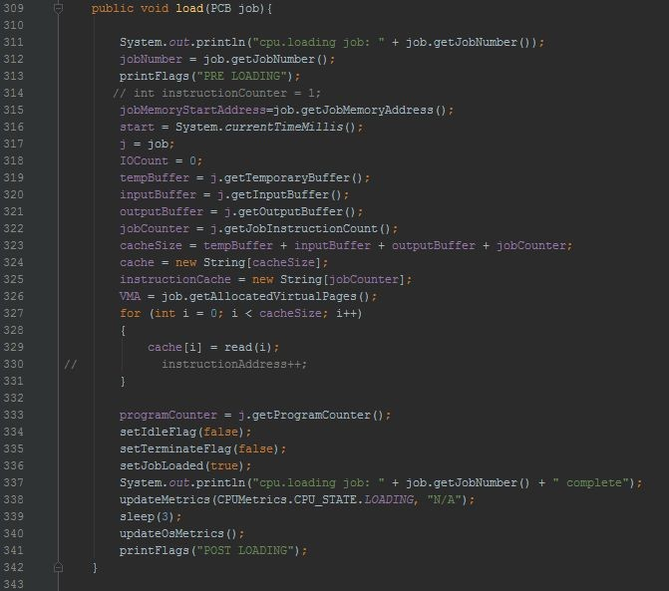

CPU run

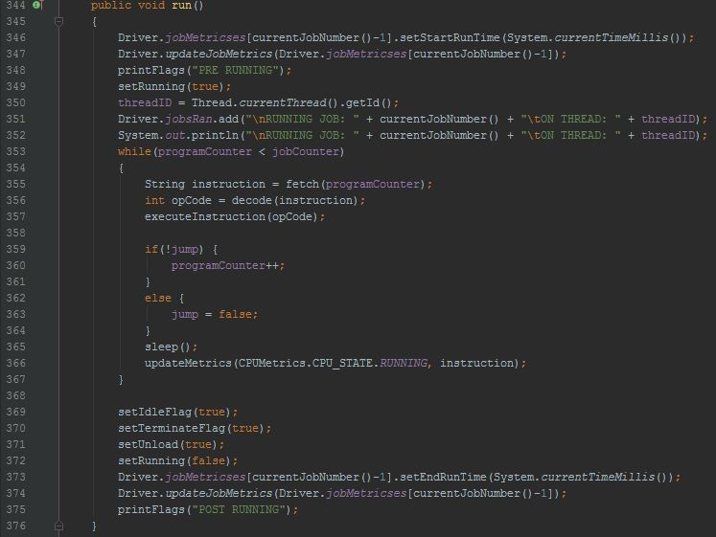

CPU decode

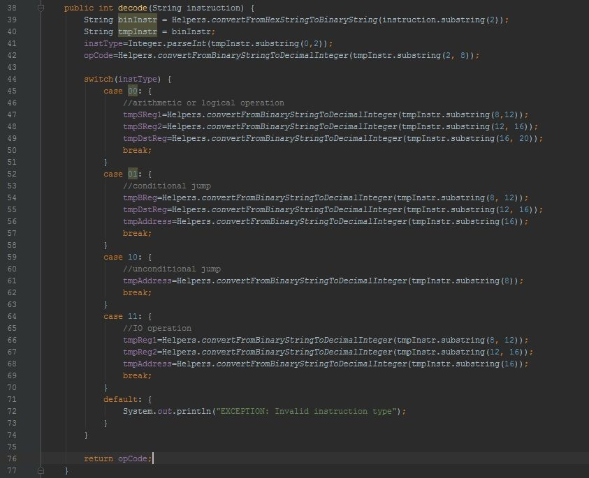

### DMA Module

This module receives the instructions that are for I/O reading or writing and call a method for a module that is not the CPU and will be able to handle the reading and writing to and from different simulated I/O devices while the Driver handles the “compute only” functionalities. This process frees the CPU of the time consuming process of transferring files leaving it more time for computational instructions that can be handled many times faster.

DMA Read/Write

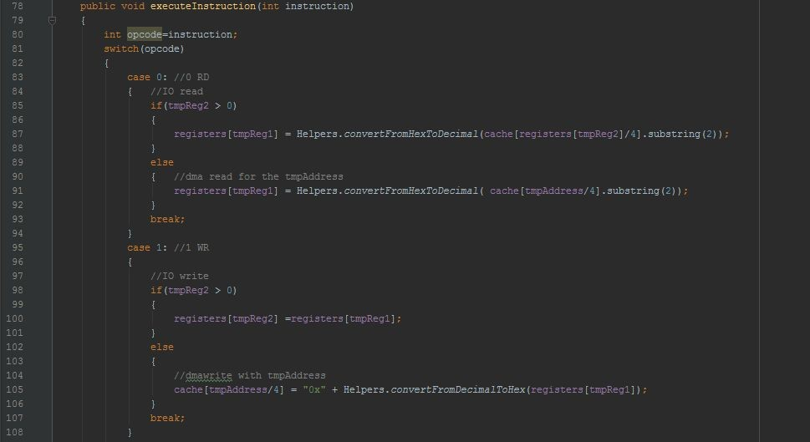

## Schedulers

### LongTerm-Scheduler Class

The LongTerm-Scheduler loads jobs into RAM. Our Long-term scheduler works by checking if our PCB in disk is empty or not. If not empty and we can add, our Long-term scheduler will look for an empty frame to load our instructions into. Our Long-Term Scheduler will continue to loop until our PCB within the disk is empty.

### ShortTermScheduler Module

The ShortTermScheduler is responsible for scheduling the jobs for execution based on one of the desired scheduling methods: First In First Out (FIFO), Priority Scheduling, or Shortest Job First (SJF). the scheduling method changes the order in which the dispatcher calls the jobs from RAM to the CPU. This module loads jobs into the ready queue for the dispatcher. The STS calls the dispatcher according to the scheduling choice, which then loads the jobs onto the CPU.

### Dispatcher Module

The Dispatcher module is responsible for loading jobs onto the CPU. The dispatcher has been modified for phase 2 to support job dispatching to multiple CPU cores. The dispatcher is responsible for setting jobs that have been successfully completed to a terminated state, load jobs onto currently idle CPU’s, and to send the “end run, all jobs complete” signal to the OS. In order to accomplish this, the dispatcher runs through the PCB and loads the necessary jobs onto the CPU while gathering the metric data for each job.

Dispatcher loadJobs()

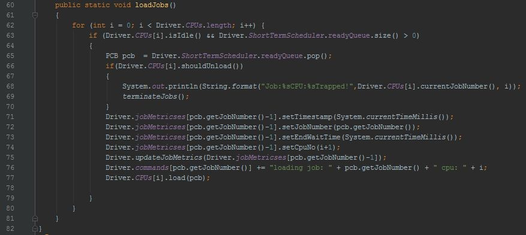

Dispatcher terminateJobs()

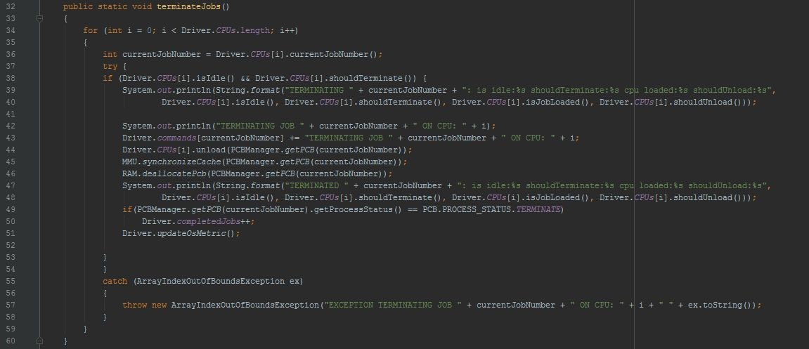

## Memory System

### MMU Module

This is the memory management unit.​ ​This module facilitates the communication between other modules and the RAM.

MMU read/write

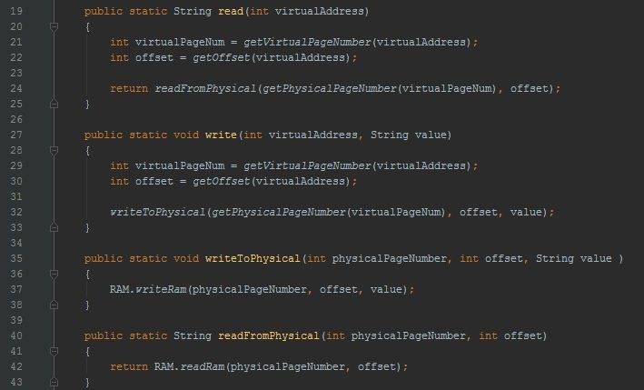

### RAM Class

The virtual version of our RAM that processes are loaded into. The RAM module utilizes a similar structure to the Disk module, which is an array of strings to represent 4 bit words. The

RAM module is wrapped by the MMU such that no other modules interact directly with it.

RAM init

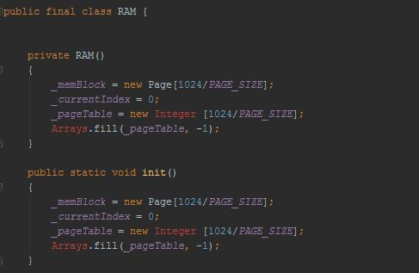

### Disk Class

Our Disk Class, is just loading our PCB object and holding instructions for later use from the schedulers.

### Page Module

The page module constructs the pages that are used by the system for paging. It contains sizing information, the information the pages hold, and functions to write to the page

## Driver Class

Our driver class is basically Functions as the main() of the operating system. This module is where all other modules are called upon to function meaningfully together. First it calls the loader module, then it calls the schedulers, which in turn call the dispatcher. The driver loops until no more instructions remain in the ready queue. This functionality is under the run() method, which would be the equivalent of compute only.

Driver run()

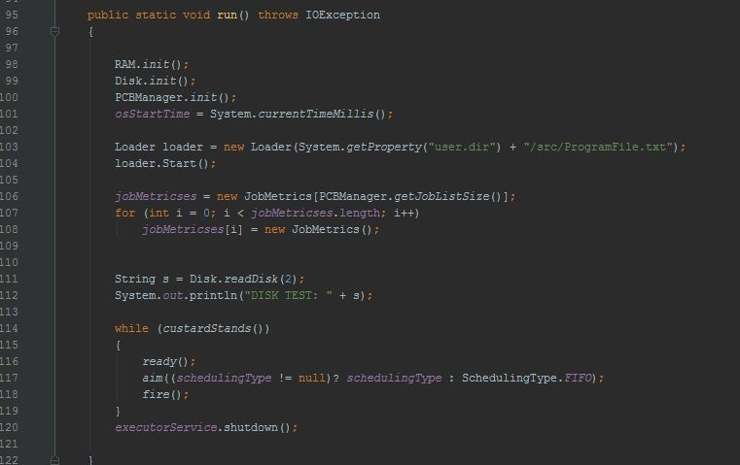

Driver computeOnly()

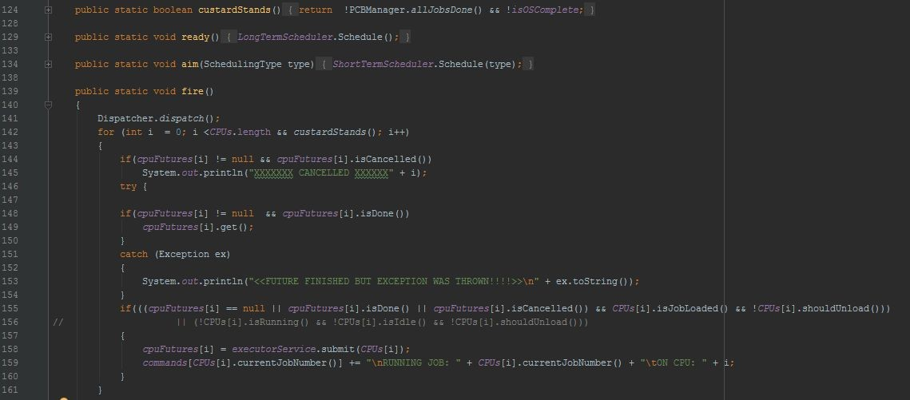

## Loader Class

## Process Control Block

### PCB Class

### 

Our PCB class, is a data structure which, contains all the information needed for each job in the CPU. This information includes, job number, priority, burst time, cache information, etc. Our PCB class has a constructor which takes in jobNumber, priority, numberofInstructions, and the jobDiskLocation for later use.

## Helpers Module

Helps with processes that may be required of multiple other modules. These processes are small operations here and there that perform a variety of tasks that assist other modules in completing their task. This module performs actions such as converting a hexadecimal number to a decimal number and vice versa.

## GUI Implementation

The following modules were implemented upon completion of the project’s primary goal. The below modules build off of each other to facilitate the ability to better view metrics put out by the emulated OS while at the same time giving the OS a unique look and feel that performs both aesthetic and metrology related functionalities. The below modules wrap the driver module and serve as an extension to the main OS modules.

### MainFrame

This module is responsible creating the GUI for the OS. This creates a usable interface that provides a unique look for our simulated OS. Everything is run from within the MainFrame module.

### ConsoleConstructor Module

The ConsoleConstructor module is responsible for creating a console like output from the system. This in essence creates a console unit that functions as a commandline interface with the system.

### ConsoleStream Module

The ConsoleStream module is used to provide the ConsoleConstructor with its function and appearance.

### CPUMetricsPanel Module

This module is responsible for reading in the process events and then displaying results as it performs measurements against the metrics required in the phase report specifications.

### OSMetricsPanel Module

This module creates the display for the metrics taken by the OS as it runs. These metrics include total jobs, total jobs completed, jobs in progress, average wait time, and average run time.

### JobTable Module

The job table is a visual representation of the jobs and their current metrics. It updates the table as each job is ran and displays the job’s timestamp, job number, assigned CPU, wait time, run time, and blocks used.

### MetricsDialogue Module

This module extends some of the other GUI modules and uses them to create a metrics display that is viewable during runtime.

# Simulation and Data Analysis

The OS is simulated, so the system runs in virtual space. The system begins by asking the user to enter the scheduling type that they wish to use, then the system asks the user the amount of CPU cores desired during the simulation. The Simulation then starts from the Driver. The Driver creates the simulated CPU, RAM, Disk, Long Term Scheduler, Short Term Scheduler, PCB Manager, and Loader needed by the system. Once the system starts, the Loader loads everything from the program file into the simulated Disk while creating a PCB for each process as it is loaded in. After everything is loaded in and the scheduling type and number of CPU cores has been passed into the system, the Drive starts our “compute only” equivalent. This is a 3 part cycle of loading jobs into RAM , scheduling the jobs in RAM according to the prefered scheduling method, and then dispatching the jobs to the CPU to be run. This process runs continuously until all of the jobs to be completed have been run. The first step of the cycle relies on the LongTermScheduler module to load jobs from the disk into RAM. As the jobs on ram are completed, the LongTermScheduler will add more jobs from Disk to RAM to be run. The second part of the cycle is scheduling the jobs in ram to be dispatched. This is done with the ShortTermScheduler module. The ShortTermScheduler uses the desired scheduling algorithm taken in from the user and schedules the job order in ram based on that input. The third part of the cycle is dispatching these jobs from RAM to the CPU. This is accomplished with the Dispatcher module. The LongTermScheduler will read in jobs from disk until everything has been read in. At that point the LongTermScheduler sends a signal that indicates that all jobs have been read in from Disk. Once the CPU finishes running the jobs currently in RAM the cycle is ended and the system has completed its running cycle.

For the simulation of our OS we ran the tests and gathered the metrics under 2 running conditions. The first running condition uses 1 CPU core, and the second runs under the N­CPU core condition. As mentioned earlier, JequirityOS is capable of N­CPU and has been tested at up to 2048 emulated cores, but because of the limitation of our RAM, only 12 CPUs are ever used based on the size of the jobs given in the instruction set. For our N­CPU condition we chose to run the OS with 8 simulated cores.

The simulation was run on three scheduling algorithms: Priority Scheduling, First In First Out(FIFO), and Shortest Job First(SJF). During each run, our simulation captured a number of metrics to be used in data analysis of the CPU performance. The items gathered were: the System time at which the job started, the job number, which CPU core the job ran on, the wait time, the run time, the number of pages used for each job, and the number of I/O operations performed by each job.

The results for each run can be found below in its appropriate category:

1 CPU Core simulation and Data

Priority Scheduling Results:

|  |  |  |  |  |  |  |
| --- | --- | --- | --- | --- | --- | --- |
| **SYSTEM TIME** | **JOB #** | **WAIT TIME** |  | **RUN TIME** | **BLOCKS USED / 64 = pages used** | **I/O Used** |
| **PRIO** |  |  |  |  |  |  |
| 1461184722200 | 1 |  | 3 | 7 | 67 | 12 |
| 1461184722211 | 9 |  | 13 | 8 | 68 | 12 |
| 1461184722220 | 14 |  | 22 | 2 | 63 | 10 |
| 1461184722223 | 5 |  | 26 | 6 | 72 | 12 |
| 1461184722229 | 11 |  | 9 | 3 | 67 | 12 |
| 1461184722234 | 2 |  | 37 | 4 | 72 | 12 |
| 1461184722239 | 4 |  | 42 | 3 | 63 | 12 |
| 1461184722242 | 7 |  | 45 | 2 | 63 | 12 |
| 1461184722245 | 21 |  | 2 | 2 | 63 | 13 |
| 1461184722249 | 26 |  | 3 | 2 | 63 | 8 |
| 1461184722251 | 15 |  | 12 | 3 | 68 | 11 |
| 1461184722255 | 3 |  | 58 | 2 | 68 | 12 |
| 1461184722260 | 17 |  | 4 | 3 | 72 | 12 |
| 1461184722263 | 6 | 66 | | 2 | 68 | 12 |
| 1461184722266 | 19 | 2 | | 1 | 72 | 10 |
| 1461184722269 | 20 | 2 | | 2 | 68 | 12 |
| 1461184722272 | 16 | 48 | | 1 | 63 | 5 |
| 1461184722273 | 23 | 1 | | 2 | 67 | 11 |
| 1461184722277 | 24 | 3 | | 3 | 68 | 12 |
| 1461184722281 | 30 | 32 | | 2 | 63 | 11 |
| 1461184722284 | 12 | 54 | | 3 | 72 | 12 |
| 1461184722288 | 25 | 11 | | 2 | 67 | 7 |
| 1461184722290 | 28 | 2 | | 2 | 72 | 12 |
| 1461184722294 | 29 | 3 | | 3 | 68 | 12 |
| 1461184722297 | 27 | 16 | | 2 | 67 | 12 |
| 1461184722301 | 10 | 89 | | 2 | 72 | 12 |
| 1461184722304 | 22 | 35 | | 2 | 72 | 12 |
| 1461184722308 | 13 | 74 | | 3 | 68 | 12 |
| 1461184722312 | 18 | 52 | | 3 | 68 | 12 |
| 1461184722315 | 8 | 117 | | 2 | 63 | 12 |

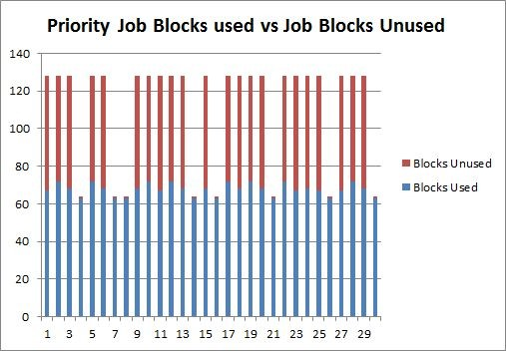

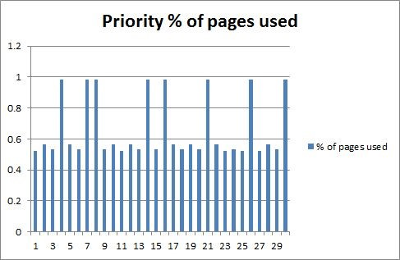

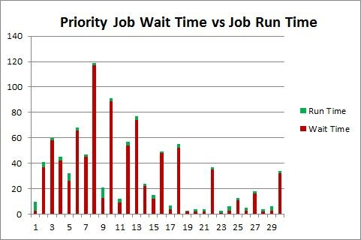

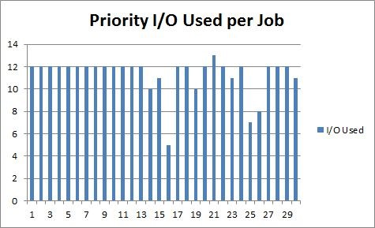

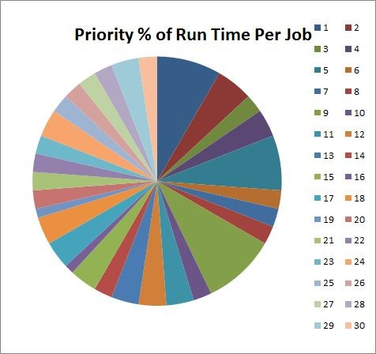

First In First Out(FIFO) Scheduling Results:

|  |  |  |  |  |  |  |  |  |
| --- | --- | --- | --- | --- | --- | --- | --- | --- |
| **SYSTEM TIME** | **JOB #** |  | **WAIT TIME** |  | **RUN TIME** |  | **BLOCKS USED / 64 = pages used** | **I/O Used** |
| **FIFO** |  |  |  |  |  |  |  |  |
| 1461184785147 |  | 1 |  | 3 |  | 6 | 67 | 12 |
| 1461184785157 |  | 2 |  | 13 |  | 5 | 72 | 12 |
| 1461184785164 |  | 3 |  | 19 |  | 5 | 68 | 12 |
| 1461184785170 |  | 4 |  | 25 |  | 3 | 63 | 12 |
| 1461184785174 |  | 5 |  | 29 |  | 4 | 72 | 12 |
| 1461184785179 |  | 6 |  | 34 |  | 3 | 68 | 12 |
| 1461184785182 |  | 7 |  | 37 |  | 2 | 63 | 12 |
| 1461184785186 |  | 8 |  | 41 |  | 2 | 63 | 12 |
| 1461184785189 | 9 | | 44 | | 4 | | 68 | 12 |
| 1461184785193 | 10 | | 35 | | 3 | | 72 | 12 |
| 1461184785197 | 11 | | 33 | | 4 | | 67 | 12 |
| 1461184785201 | 12 | | 31 | | 3 | | 72 | 12 |
| 1461184785205 | 13 | | 26 | | 3 | | 68 | 12 |
| 1461184785209 | 14 | | 64 | | 2 | | 63 | 10 |
| 1461184785212 | 15 | | 29 | | 3 | | 68 | 11 |
| 1461184785216 | 16 | | 42 | | 1 | | 63 | 5 |
| 1461184785218 | 17 | | 24 | | 3 | | 72 | 12 |
| 1461184785222 | 18 | | 24 | | 3 | | 68 | 12 |
| 1461184785225 | 19 | | 24 | | 2 | | 72 | 10 |
| 1461184785228 | 20 | | 23 | | 2 | | 68 | 12 |
| 1461184785232 | 21 | | 46 | | 2 | | 63 | 13 |
| 1461184785235 | 22 | | 26 | | 3 | | 72 | 12 |
| 1461184785239 | 23 | | 23 | | 3 | | 67 | 11 |
| 1461184785243 | 24 | | 21 | | 3 | | 68 | 12 |
| 1461184785248 | 25 | | 22 | | 2 | | 67 | 7 |
| 1461184785251 | 26 | | 61 | | 2 | | 63 | 8 |
| 1461184785254 | 27 | | 25 | | 3 | | 67 | 12 |
| 1461184785258 | 28 | | 26 | | 3 | | 72 | 12 |
| 1461184785262 | 29 | | 27 | | 2 | | 68 | 12 |
| 1461184785265 | 30 | | 53 | | 2 | | 63 | 11 |

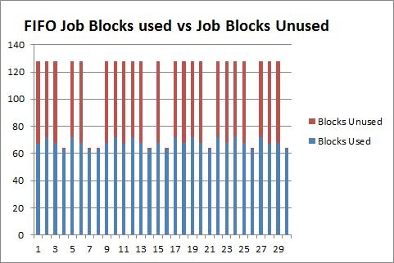

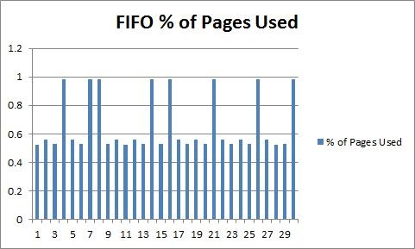

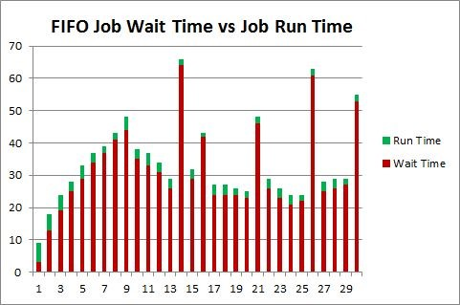

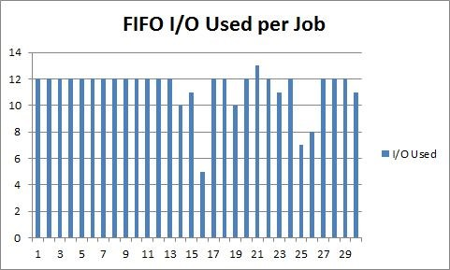

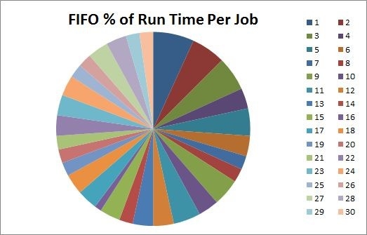

Shortest Job First Scheduling Results:

|  |  |  |  |  |  |  |  |  |
| --- | --- | --- | --- | --- | --- | --- | --- | --- |
| **SYSTEM TIME** | **JOB #** |  | **WAIT TIME** |  | **RUN TIME** |  | **BLOCKS USED / 64 = pages used** | **I/O Used** |
| **SJF** |  |  |  |  |  |  |  |  |
| 1461184818325 |  | 4 |  | 2 |  | 4 | 63 | 12 |
| 1461184818334 |  | 7 |  | 10 |  | 3 | 63 | 12 |
| 1461184818339 |  | 8 |  | 15 |  | 4 | 63 | 12 |
| 1461184818343 |  | 14 |  | 19 |  | 2 | 63 | 10 |
| 1461184818347 |  | 16 |  | 12 |  | 2 | 63 | 5 |
| 1461184818349 |  | 21 |  | 10 |  | 2 | 63 | 13 |
| 1461184818353 |  | 26 |  | 9 |  | 2 | 63 | 8 |
| 1461184818356 |  | 30 |  | 8 |  | 2 | 63 | 11 |
| 1461184818360 |  | 1 |  | 37 |  | 3 | 67 | 12 |
| 1461184818363 |  | 11 |  | 3 |  | 2 | 67 | 12 |
| 1461184818367 | 3 | | 44 | | 2 | | 68 | 12 |
| 1461184818371 | 6 | | 47 | | 3 | | 68 | 12 |
| 1461184818374 | 9 | | 50 | | 2 | | 68 | 12 |
| 1461184818378 | 13 | | 10 | | 2 | | 68 | 12 |
| 1461184818380 | 15 | | 9 | | 1 | | 68 | 11 |
| 1461184818383 | 18 | | 5 | | 2 | | 68 | 12 |
| 1461184818386 | 20 | | 3 | | 2 | | 68 | 12 |
| 1461184818389 | 2 | | 66 | | 2 | | 72 | 12 |
| 1461184818392 | 23 | | 3 | | 3 | | 67 | 11 |
| 1461184818395 | 24 | | 2 | | 2 | | 68 | 12 |
| 1461184818399 | 25 | | 3 | | 1 | | 67 | 7 |
| 1461184818401 | 27 | | 2 | | 3 | | 67 | 12 |
| 1461184818405 | 5 | | 82 | | 2 | | 72 | 12 |
| 1461184818408 | 29 | | 3 | | 2 | | 68 | 12 |
| 1461184818412 | 10 | | 58 | | 2 | | 72 | 12 |
| 1461184818415 | 12 | | 51 | | 2 | | 72 | 12 |
| 1461184818418 | 17 | | 43 | | 3 | | 72 | 12 |
| 1461184818422 | 19 | | 41 | | 3 | | 72 | 10 |
| 1461184818426 | 22 | | 40 | | 2 | | 72 | 12 |
| 1461184818428 | 28 | | 27 | | 2 | | 72 | 12 |

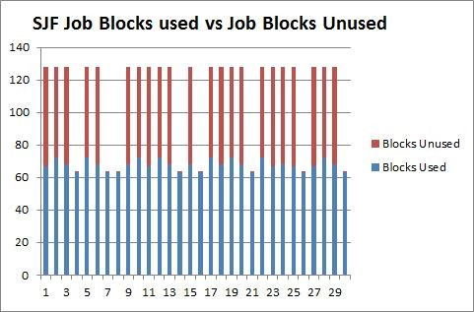

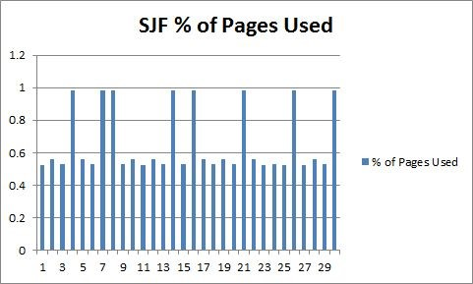

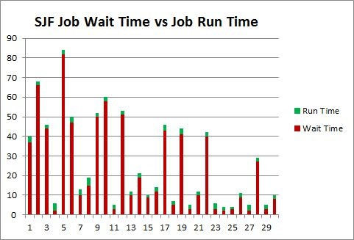

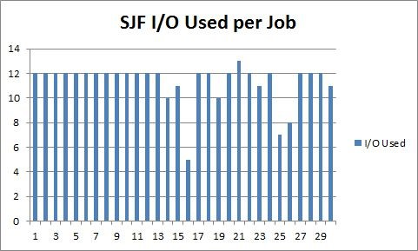

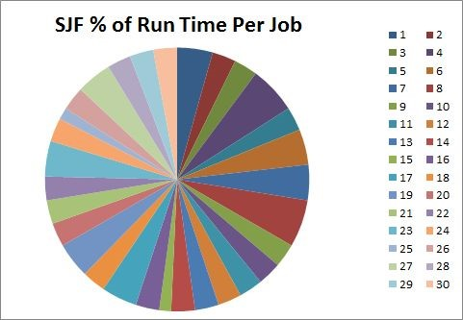

## **N­CPU Cores Where N = 8 CPU Cores**

Priority Scheduling 8 CPU Cores Results:

|  |  |  |  |  |  |  |  |  |  |
| --- | --- | --- | --- | --- | --- | --- | --- | --- | --- |
| **SYSTEM TIME** | **JOB #** |  | **CPU #** |  | **WAIT TIME** |  | **RUN TIME** | **BLOCKS USED / 64 = pages used** | **I/Os Used** |
| PRIO |  |  |  |  |  |  |  |  |  |
| 1461184594806 |  | 1 |  | 1 |  | 3 | 16 | 67 | 12 |
| 1461184594808 |  | 9 |  | 2 |  | 4 | 15 | 68 | 12 |
| 1461184594809 |  | 14 |  | 3 |  | 5 | 10 | 63 | 10 |
| 1461184594809 |  | 5 |  | 4 |  | 6 | 16 | 72 | 12 |
| 1461184594809 |  | 2 |  | 5 |  | 6 | 15 | 72 | 12 |
| 1461184594809 |  | 4 |  | 6 |  | 6 | 12 | 63 | 12 |
| 1461184594809 |  | 7 |  | 7 |  | 5 | 12 | 63 | 12 |
| 1461184594810 |  | 3 |  | 8 |  | 7 | 15 | 68 | 12 |
| 1461184594826 |  | 6 |  | 3 |  | 23 | 4 | 68 | 12 |
| 1461184594826 |  | 8 |  | 6 |  | 22 | 3 | 63 | 12 |
| 1461184594831 | 16 | | 1 | | 4 | | 1 | 63 | 5 |
| 1461184594832 | 10 | | 2 | | 5 | | 3 | 72 | 12 |
| 1461184594834 | 11 | | 1 | | 2 | | 7 | 67 | 12 |
| 1461184594835 | 17 | | 3 | | 2 | | 7 | 72 | 12 |
| 1461184594835 | 21 | | 4 | | 2 | | 5 | 63 | 13 |
| 1461184594835 | 15 | | 5 | | 2 | | 7 | 68 | 11 |
| 1461184594835 | 12 | | 6 | | 3 | | 7 | 72 | 12 |
| 1461184594835 | 13 | | 7 | | 2 | | 7 | 68 | 12 |
| 1461184594837 | 26 | | 2 | | 1 | | 4 | 63 | 8 |
| 1461184594838 | 18 | | 8 | | 2 | | 6 | 68 | 12 |
| 1461184594845 | 19 | | 2 | | 7 | | 1 | 72 | 10 |
| 1461184594847 | 20 | | 1 | | 1 | | 5 | 68 | 12 |
| 1461184594848 | 23 | | 2 | | 2 | | 6 | 67 | 11 |
| 1461184594848 | 24 | | 3 | | 2 | | 6 | 68 | 12 |
| 1461184594849 | 25 | | 4 | | 3 | | 2 | 67 | 7 |
| 1461184594849 | 22 | | 5 | | 3 | | 6 | 72 | 12 |
| 1461184594850 | 29 | | 6 | | 0 | | 6 | 68 | 12 |
| 1461184594850 | 28 | | 7 | | 0 | | 6 | 72 | 12 |
| 1461184594850 | 27 | | 8 | | 1 | | 6 | 67 | 12 |
| 1461184594853 | 30 | | 4 | | 0 | | 3 | 63 | 11 |

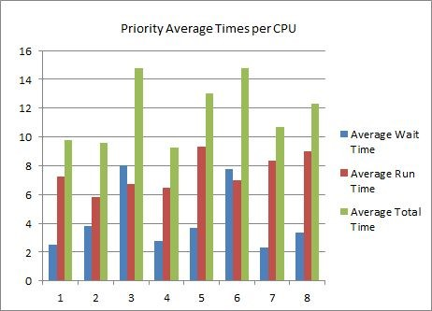

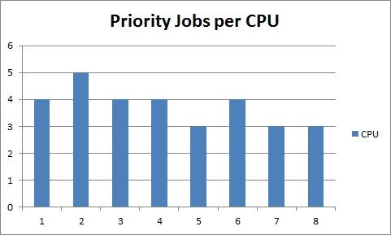

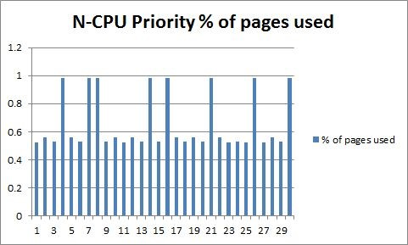

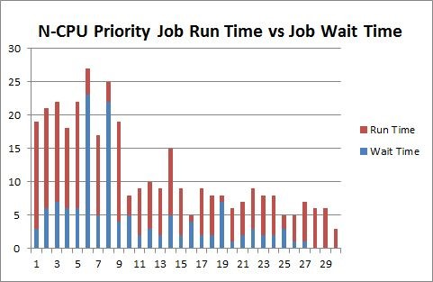

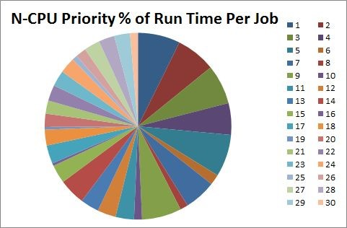

First In First Out(FIFO) Scheduling 8 CPU Cores Results:

|  |  |  |  |  |  |  |  |  |
| --- | --- | --- | --- | --- | --- | --- | --- | --- |
| **SYSTEM TIME** | **JOB #** | **CPU #** |  | **WAIT TIME** |  | **RUN TIME** | **BLOCKS USED / 64 = pages used** | **I/Os Used** |
| **FIFO** |  |  |  |  |  |  |  |  |
| 1461184653796 | 1 |  | 1 |  | 3 | 15 | 67 | 12 |
| 1461184653797 | 2 |  | 2 |  | 4 | 16 | 72 | 12 |
| 1461184653797 | 3 |  | 3 |  | 4 | 16 | 68 | 12 |
| 1461184653798 | 4 |  | 4 |  | 5 | 12 | 63 | 12 |
| 1461184653798 | 5 |  | 5 |  | 5 | 15 | 72 | 12 |
| 1461184653798 | 6 |  | 6 |  | 5 | 14 | 68 | 12 |
| 1461184653798 | 7 |  | 7 |  | 5 | 11 | 63 | 12 |
| 1461184653798 | 8 |  | 8 |  | 5 | 11 | 63 | 12 |
| 1461184653819 | 9 |  | 1 |  | 26 | 5 | 68 | 12 |
| 1461184653819 | 14 |  | 2 |  | 25 | 2 | 63 | 10 |
| 1461184653820 | 10 |  | 3 |  | 1 | 9 | 72 | 12 |
| 1461184653820 | 11 |  | 4 |  | 0 | 9 | 67 | 12 |
| 1461184653820 | 12 | 5 | | 0 | | 10 | 72 | 12 |
| 1461184653821 | 13 | 6 | | 1 | | 9 | 68 | 12 |
| 1461184653821 | 15 | 7 | | 1 | | 7 | 68 | 11 |
| 1461184653821 | 16 | 8 | | 1 | | 2 | 63 | 5 |
| 1461184653823 | 17 | 2 | | 3 | | 9 | 72 | 12 |
| 1461184653826 | 21 | 1 | | 2 | | 6 | 63 | 13 |
| 1461184653827 | 18 | 8 | | 0 | | 6 | 68 | 12 |
| 1461184653830 | 26 | 7 | | 3 | | 2 | 63 | 8 |
| 1461184653835 | 19 | 1 | | 5 | | 1 | 72 | 10 |
| 1461184653836 | 20 | 2 | | 0 | | 8 | 68 | 12 |
| 1461184653836 | 22 | 3 | | 0 | | 9 | 72 | 12 |
| 1461184653837 | 23 | 4 | | 1 | | 8 | 67 | 11 |
| 1461184653837 | 24 | 5 | | 1 | | 9 | 68 | 12 |
| 1461184653837 | 25 | 6 | | 1 | | 5 | 67 | 7 |
| 1461184653837 | 27 | 7 | | 1 | | 9 | 67 | 12 |
| 1461184653837 | 28 | 8 | | 1 | | 9 | 72 | 12 |
| 1461184653839 | 29 | 1 | | 0 | | 9 | 68 | 12 |
| 1461184653844 | 30 | 6 | | 0 | | 4 | 63 | 11 |

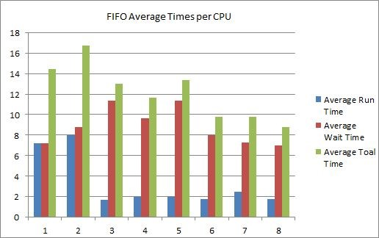

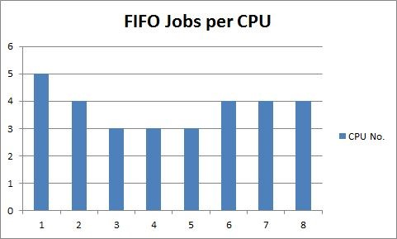

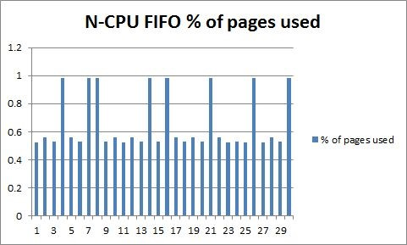

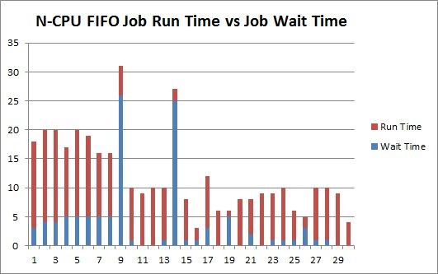

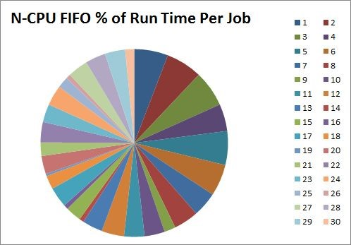

Shortest Job First() Scheduling 8 Core Results:

|  |  |  |  |  |  |  |  |  |
| --- | --- | --- | --- | --- | --- | --- | --- | --- |
| **SYSTEM TIME** | **JOB #** | **CPU #** |  | **WAIT TIME** |  | **RUN TIME** | **BLOCKS USED / 64 = pages used** | **I/Os Used** |
| **SJF** |  |  |  |  |  |  |  |  |
| 1461184694730 | 4 |  | 1 |  | 3 | 11 | 63 | 12 |
| 1461184694731 | 7 |  | 2 |  | 4 | 11 | 63 | 12 |
| 1461184694732 | 8 |  | 3 |  | 5 | 11 | 63 | 12 |
| 1461184694732 | 14 |  | 4 |  | 5 | 9 | 63 | 10 |
| 1461184694732 | 1 |  | 5 |  | 6 | 14 | 67 | 12 |
| 1461184694732 | 3 |  | 6 |  | 5 | 14 | 68 | 12 |
| 1461184694733 | 6 |  | 7 |  | 6 | 14 | 68 | 12 |
| 1461184694733 | 9 |  | 8 |  | 6 | 13 | 68 | 12 |
| 1461184694752 | 2 |  | 1 |  | 26 | 5 | 72 | 12 |
| 1461184694752 | 5 |  | 2 |  | 25 | 5 | 72 | 12 |
| 1461184694753 | 16 |  | 3 |  | 0 | 3 | 63 | 5 |
| 1461184694753 | 21 | 4 | | 0 | | 7 | 63 | 13 |
| 1461184694753 | 11 | 5 | | 1 | | 9 | 67 | 12 |
| 1461184694753 | 13 | 6 | | 1 | | 9 | 68 | 12 |
| 1461184694754 | 15 | 7 | | 1 | | 8 | 68 | 11 |
| 1461184694754 | 10 | 8 | | 2 | | 9 | 72 | 12 |
| 1461184694759 | 12 | 1 | | 7 | | 5 | 72 | 12 |
| 1461184694760 | 26 | 2 | | 0 | | 1 | 63 | 8 |
| 1461184694761 | 18 | 3 | | 1 | | 3 | 68 | 12 |
| 1461184694762 | 17 | 4 | | 2 | | 3 | 72 | 12 |
| 1461184694768 | 30 | 2 | | 5 | | 1 | 63 | 11 |
| 1461184694769 | 23 | 1 | | 0 | | 7 | 67 | 11 |
| 1461184694769 | 25 | 3 | | 0 | | 2 | 67 | 7 |
| 1461184694770 | 27 | 4 | | 1 | | 8 | 67 | 12 |
| 1461184694770 | 20 | 5 | | 1 | | 7 | 68 | 12 |
| 1461184694770 | 24 | 6 | | 1 | | 8 | 68 | 12 |
| 1461184694770 | 19 | 7 | | 1 | | 7 | 72 | 10 |
| 1461184694770 | 22 | 8 | | 1 | | 8 | 72 | 12 |
| 1461184694772 | 28 | 2 | | 0 | | 7 | 72 | 12 |
| 1461184694775 | 29 | 3 | | 0 | | 6 | 68 | 12 |

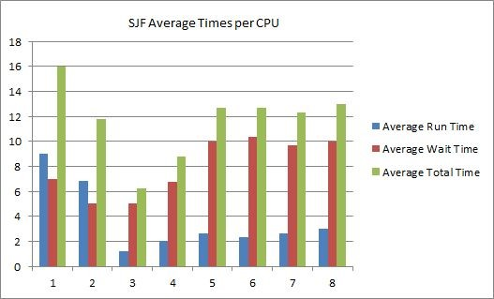

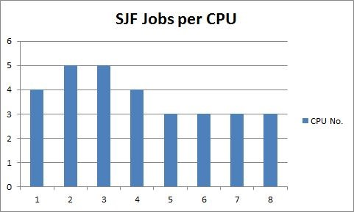

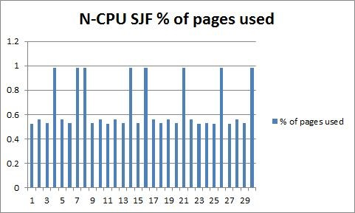

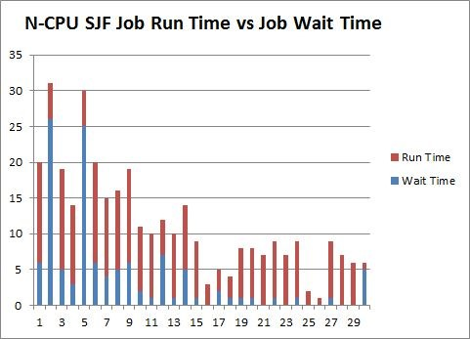

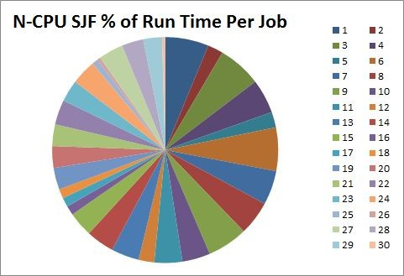

### **1 CPU Core vs. 8 CPU Cores(N­CPU)**

Job Time Averages Based on Scheduling Type and CPU Core Amount

|  |  |  |  |  |
| --- | --- | --- | --- | --- |
| Scheduling Type | CPU Core Amount | Wait Time(ms) | Run Time(ms) | Total Time(ms) |
| Priority | 1 | 29.43 | 2.80 | 32.23 |
| Priority | N | 4.37 | 7.30 | 11.67 |
| FIFO | 1 | 31.00 | 2.93 | 33.93 |
| FIFO | N | 3.63 | 8.57 | 12.20 |
| SJF | 1 | 23.80 | 2.30 | 26.10 |
| SJF | N | 3.87 | 7.50 | 11.37 |

Total Job Time Averages

|  |  |  |  |  |
| --- | --- | --- | --- | --- |
| Core Type | CPU Core Amount | Wait Time(ms) | Run Time(ms) | Total Time(ms) |
| 1 CPU Core | 1 | 28.07 | 2.67 | 30.74 |
| N­CPU Cores | 8 | 3.96 | 7.79 | 11.75 |

# Conclusions

In terms of scheduling algorithms, we tested three: Priority Scheduling, First In First Out(FIFO), and Shortest Job First(SJF). When comparing the speed of the algorithms, SJF took the least amount of time for jobs to run. The wait time, run time, and total time for the SJF algorithm were faster than both FIFO and Priority on all accounts in our measurements. The next fastest scheduling algorithm was Priority Scheduling, which had the second fastest measurements on all accounts when compared to the other scheduling algorithms except under wait time in the N­CPU condition. FIFO had the second shortest wait time when compared to the other algorithms when looking at the N­CPU cases. FIFO scored as the worst scheduling type when looking at the three we implemented. Overall, the SJF algorithm performed the fastest on average, due to its performance over multiple CPUs.

When comparing the results from running the instruction set with 1 CPU core and the N­CPU cores, the wait time dropped dramatically with extra cores. For all of the wait times across the scheduling algorithms, when run with 8 CPU cores, the time was at most one sixth the wait time of the results found in the single CPU equivalent, a significant margin. Although the wait times were cut by such a large proportion, the run times increased by a factor of at least 2.5. Even though this jump in run time occurs when increasing the amount of cores, the greatly reduced wait time balances the total job time to a fraction of the job time when run on 1 CPU. The best number of CPUs for the OS is around 8 cores, more could increase the speed, but due to the size of our RAM, only 12 CPUs would be loaded at a time. With this in mind, we could run several more CPU cores, but for our allotted RAM this becomes less practical.

Jobs with less I/O ran slightly faster than those with more, but the difference was negligible in the given scale of the project.

To summarize, the fastest scheduling type was Shortest Job First, and the optimal number of

CPUs was 8, but any amount up to 12 was about as efficient.